## WSL-VPNKIT Installation

Link: <https://github.com/sakai135/wsl-vpnkit>

Download the *.tar.gz file from latest release.

* <https://github.com/sakai135/wsl-vpnkit/releases>
* Move the download file to your USERPROFILE Directory (C:Users/{username} )

In PowerShell Execute the following command:

* wsl --import wsl-vpnkit --version 2 $env:USERPROFILE\wsl-vpnkit wsl-vpnkit.tar.gz

Next In PowerShell, execute the following command to start wsl-vpnkit

* wsl.exe -d wsl-vpnkit --cd /app wsl-vpnkit

To ensure wsl-vpnkit is running, try:

* wsl -l -v

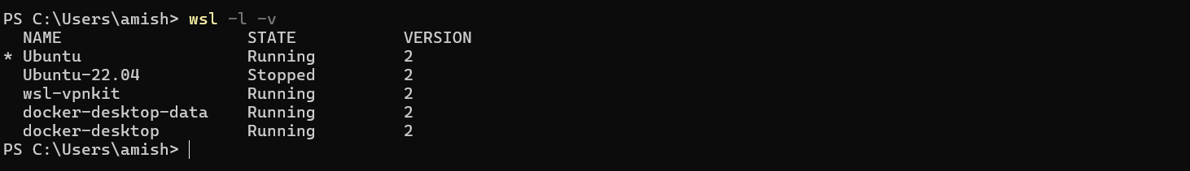

** wsl may not be fun automatically every time when ever you start the computer. So you have to Setup ***system***

***Open the Terminal and go to your selected distribution! And execute the following command.***

# wsl-vpnkit setup as a distro

wsl.exe -d wsl-vpnkit --cd /app cat /app/wsl-vpnkit.service | sudo tee /etc/systemd/system/wsl-vpnkit.service

# copy and edit for wsl-vpnkit setup as a standalone script

sudo cp ./wsl-vpnkit.service /etc/systemd/system/

sudo nano /etc/systemd/system/wsl-vpnkit.service

# enable the service

sudo systemctl enable wsl-vpnkit

# start and check the status of the service

sudo systemctl start wsl-vpnkit

systemctl status wsl-vpnkit

after that restart your system. And start the Ubuntu distribution and Check the wsl-vpnkit status.

** if you don’t want to use shell execution. Please run our .sh file, it will do automatically

./wsl-vpnkit_startup_setup.sh

## Nvidia-Driver Installation:

Link: <https://www.nvidia.com/download/find.aspx>

Click on Link and select the appropriate option as shown below:

Click on search, it will give you list of available versions of driver.

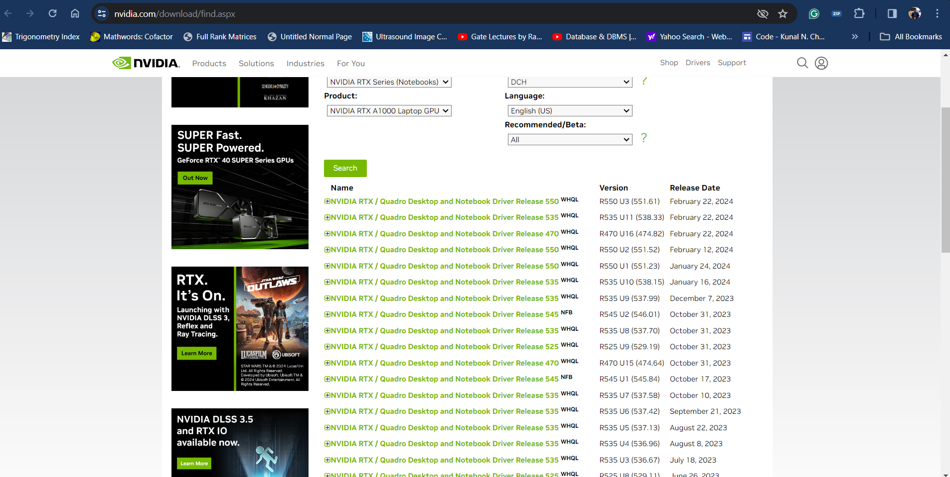

Download the driver and install it in your system. In our case we have selected **551.52** versions

## [Cuda Toolkit Installation:](https://developer.nvidia.com/cuda-downloads?target_os=Linux&target_arch=x86_64&Distribution=WSL-Ubuntu&target_version=2.0&target_type=deb_network)

Link: <https://developer.nvidia.com/cuda-downloads?target_os=Linux&target_arch=x86_64&Distribution=WSL-Ubuntu&target_version=2.0&target_type=deb_network>

Select the appropriate options:

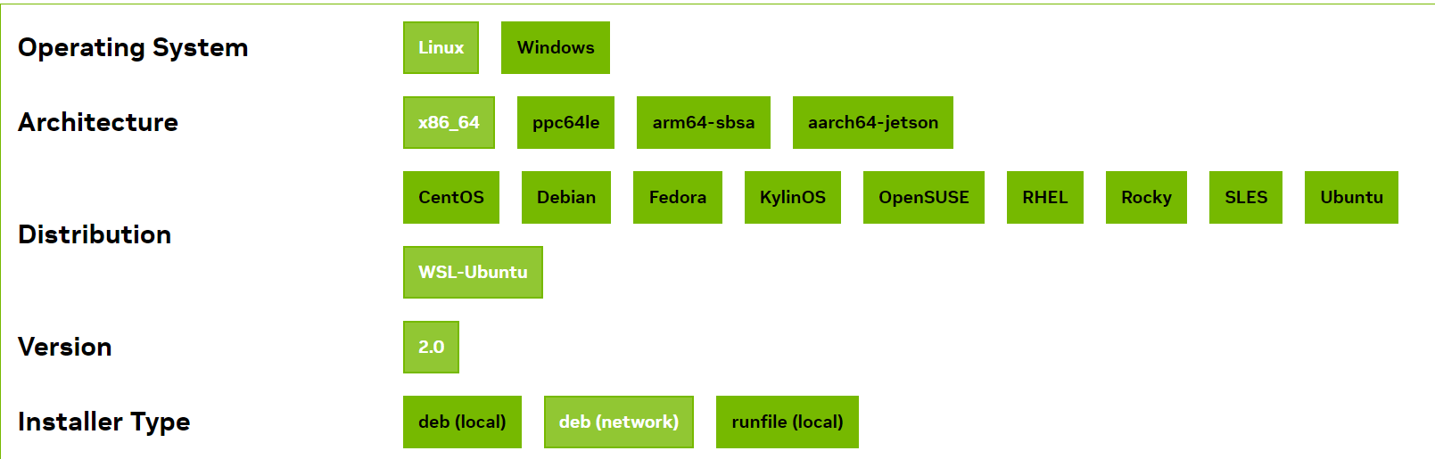

It will give you to download and install appropriate driver. As mentioned in the screen shot.

Follow the command to download and install cuda toolkit.

### Base Installer:

Installation Instructions:

* wget https://developer.download.nvidia.com/compute/cuda/repos/wsl-ubuntu/x86_64/cuda-keyring_1.1-1_all.deb
* sudo dpkg -i cuda-keyring_1.1-1_all.deb
* sudo apt-get update
* sudo apt-get -y install cuda-toolkit-12-4

Additional installation options are detailed [**here**](https://docs.nvidia.com/cuda/cuda-installation-guide-linux/#meta-packages)**.**

## Docker Installation in WSL

Link1: [https://docs.rapids.ai/install?_gl=1*s0kbz1*_ga*ODkyMzg4MDA5LjE3MTA1OTAxMjY.*_ga_RKXFW6CM42*MTcxMDY1MDc2Mi4zLjAuMTcxMDY1MDc2Mi42MC4wLjA.#wsl2-docker](https://docs.rapids.ai/install?_gl=1*s0kbz1*_ga*ODkyMzg4MDA5LjE3MTA1OTAxMjY.*_ga_RKXFW6CM42*MTcxMDY1MDc2Mi4zLjAuMTcxMDY1MDc2Mi42MC4wLjA.#wsl2-docker)

Link 2: <https://learn.microsoft.com/en-us/windows/wsl/tutorials/gpu-compute>

Download and Install. Copy command below to download and install the latest:

curl https://get.docker.com | sh

Install Latest NVIDIA Docker. Select the [appropriate supported distribution](https://nvidia.github.io/nvidia-container-runtime/):

* distribution=$(. /etc/os-release;echo $ID$VERSION_ID)
* curl -s -L https://nvidia.github.io/nvidia-docker/gpgkey | sudo gpg --dearmor -o /usr/share/keyrings/nvidia-docker-keyring.gpg
* curl -s -L https://nvidia.github.io/nvidia-docker/$distribution/nvidia-docker.list | sed 's#deb https://#deb [signed-by=/usr/share/keyrings/nvidia-docker-keyring.gpg] https://#g' | sudo tee /etc/apt/sources.list.d/nvidia-docker.list
* sudo apt-get update
* sudo apt-get install nvidia-container-runtime

Start Docker. In new terminal window run:

* sudo service docker stop.
* sudo service docker start.



Test NVIDIA Docker. In a terminal window run:

docker run --gpus all nvcr.io/nvidia/k8s/cuda-sample:nbody nbody -gpu -benchmark

* It will Check the docker image available in your local, if it is available, it will run it.
* If specific docker image is not available, it will pull it.

